Graha
Research
Research Internship · 18-Week Gantt Project Plan
Digital Product Passport Platform
Implement a Digital Product Passport (DPP) platform for connected-vehicle components that captures lifecycle, material and circularity data in an interoperable, data-sovereign data-space architecture.
18 Weeks 6 Planning Clusters 1 Thesis / Collaboration
Graha International GmbH · Herzogstandstr. 8 b, 85540 Haar, Germany · info@graha.de

Research Internship
Four 18-week Gantt Project Plans for thesis and research collaboration
Graha International GmbH offers four structured research internships, each delivered as an 18-week Gantt Project Plan organised into six best-practice planning clusters. This document details the internship highlighted below.

INTERNSHIP 01  Predictive Maintenance Platform  Design and prototype a predictive-maintenance platform for connected vehicles that combines multivariate time-series modelling, causal AI and explainable remaining-useful-life estimation. | INTERNSHIP 02  ESG Platform with GraphRAG  Build an Environmental, Social and Governance (ESG) analytics platform that uses a Knowledge Graph and Retrieval-Augmented Generation (GraphRAG) to turn fragmented sustainability data into explainable, auditable ESG insights. | INTERNSHIP 03  Digital Product Passport Platform  Implement a Digital Product Passport (DPP) platform for connected-vehicle components that captures lifecycle, material and circularity data in an interoperable, data-sovereign data-space architecture. | INTERNSHIP 04  Digital Twin Platform  Develop a Digital Twin platform that mirrors onboard vehicle systems in real time, fusing sensor telemetry with physics- and data-driven models for simulation, monitoring and what-if analysis.
This document, Digital Product Passport Platform
Implement a Digital Product Passport (DPP) platform for connected-vehicle components that captures lifecycle, material and circularity data in an interoperable, data-sovereign data-space architecture.

Our Research Plan
Digital Product Passport Platform · 18-Week Gantt Project Plan
Overview
This internship contributes to Graha International's research on data spaces and the circular economy. The intern designs and prototypes a Digital Product Passport (DPP) platform that records the lifecycle, material composition and circularity attributes of connected-vehicle components and makes them securely shareable across the value chain.
Structured as an 18-week Gantt Project Plan, the work is suitable as the practical basis for a Bachelor's or Master's thesis or a research collaboration. It emphasises interoperability, data sovereignty and alignment with emerging Digital Product Passport regulation.
Objectives
- Model product-passport data: identity, materials, lifecycle events and circularity attributes.
- Design an interoperable DPP data model aligned with relevant standards and regulation.
- Implement secure, data-sovereign sharing of passport data across value-chain actors.
- Provide passport access through a verifiable identifier and a clear user view.
- Evaluate interoperability, data integrity and access control of the platform.
Candidate Profile
- Studies in Computer Science, Information Systems, Industrial Engineering or a related field.
- Solid programming skills; interest in APIs, data modelling and distributed systems.
- Basic understanding of data spaces, identifiers and access control.
- Interest in sustainability, the circular economy and regulatory-driven systems.
- Independent, structured working style and good scientific-writing skills.
18-Week Gantt Project Plan
The plan is organised into six best-practice planning clusters spanning 18 weeks. Each cluster states its focus, key activities and a milestone that must be reached before the next cluster begins.
WEEKS 1-3 Cluster 1 - Onboarding & Foundations
Settle in, set up the working environment, and agree the detailed plan and success criteria with the academic and industrial supervisors.
KEY ACTIVITIES
- Onboarding at Graha International: tooling, data-governance and NDA briefing.
- Familiarisation with Digital Product Passport concepts, data spaces and the circular economy.
- Set up a reproducible environment: version control, experiment tracking and a containerised workspace.
- Refine scope, success criteria and the detailed 18-week work plan with the supervisor.
Milestone, Approved internship work plan and a running, reproducible development environment.

WEEKS 4-6 Cluster 2 - Literature Review & Requirements
Build the scientific foundation through a structured literature review and a precise requirements and evaluation specification.
KEY ACTIVITIES
- Structured literature review on Digital Product Passports and circular-economy data.
- Survey of DPP regulation, identifier schemes and data-space standards.
- Stakeholder and requirements analysis; definition of the core use cases and KPIs.
- Draft the conceptual approach and the evaluation methodology with metrics and baselines.
Milestone, Literature-review report and an agreed requirements and evaluation plan.

WEEKS 7-9 Cluster 3 - Data Engineering & System Architecture
Prepare the data assets and design the interoperable, data-sovereign architecture.
KEY ACTIVITIES
- Define the DPP data model: identity, materials, lifecycle events and circularity attributes.
- Map the data model to relevant interoperability standards.
- Design the platform architecture: passport store, data-space connector, API and access layers.
- Specify the verifiable identifier scheme and the data-sharing interfaces.
Milestone, Architecture design document and an interoperable DPP data model.

WEEKS 10-13 Cluster 4 - Implementation & Modelling
Implement the DPP platform and the secure data-sharing components.
KEY ACTIVITIES
- Implement the passport store and the lifecycle-event ingestion services.
- Build the data-space connector for sovereign, policy-controlled data exchange.
- Implement access control and a verifiable-identifier resolution service.
- Build the passport view that presents lifecycle and circularity data to users.
Milestone, Working DPP-platform prototype covering the core passport-sharing use case.

WEEKS 14-16 Cluster 5 - Evaluation, Validation & Hardening
Evaluate, validate and harden the prototype with a focus on interoperability.
KEY ACTIVITIES
- Define and run experiments on interoperability, data integrity and access control.
- Validate passport exchange against the agreed standards and use cases.
- Assess robustness and security of the sovereign data-sharing flow.
- Iterate on the data model and the connectors based on the findings.
Milestone, Evaluation report with quantitative results and a validated, hardened prototype.

WEEKS 17-18 Cluster 6 - Documentation, Thesis & Final Defence
Consolidate the documentation, draft the thesis material and present the results.
KEY ACTIVITIES
- Consolidate code, documentation and reproducibility instructions.
- Write the thesis-ready report covering method, results and limitations.
- Prepare and deliver the final presentation and a live demo.
- Hand over the platform, the data model and the backlog of future work to Graha.
Milestone, Final thesis-ready report, final presentation and a complete handover package.

Expected Outcomes
- A reproducible, documented Digital Product Passport platform prototype.
- An interoperable, standards-aligned DPP data model.
- A data-sovereign passport-sharing component with access control.
- A thesis-ready scientific report on interoperable product passports.
Project Timeline (Gantt Chart)
The 18-week plan visualised as a Gantt chart across Week 1 to Week 18.
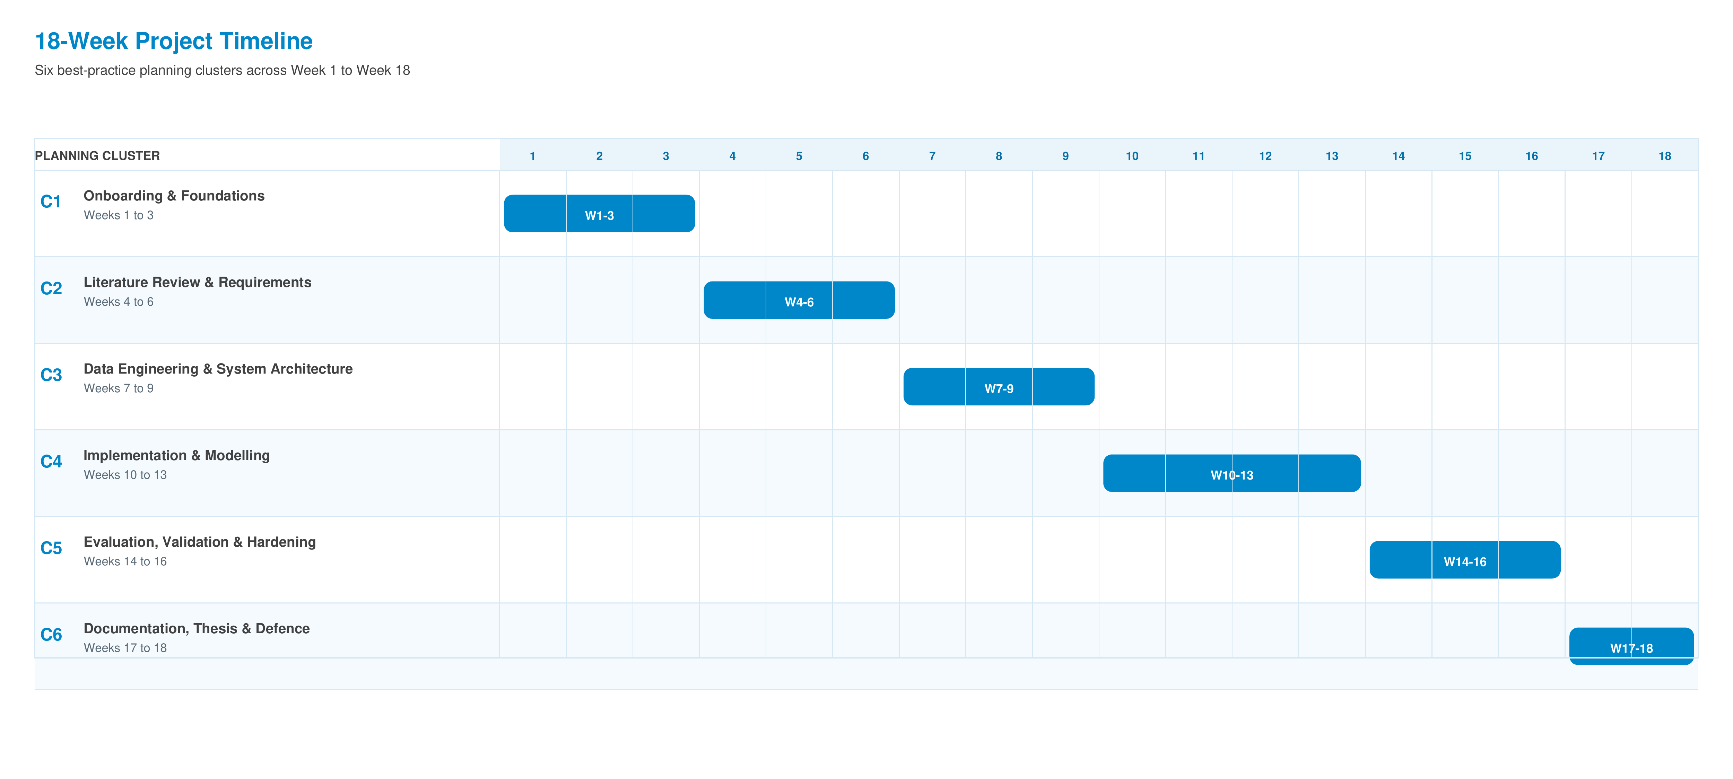

Graha International GmbH
Herzogstandstr. 8 b
85540 Haar
Germany
Contact
E-Mail: info@graha.de

