Graha
Research
Research Internship · 18-Week Gantt Project Plan
Digital Twin Platform
Develop a Digital Twin platform that mirrors onboard vehicle systems in real time, fusing sensor telemetry with physics- and data-driven models for simulation, monitoring and what-if analysis.
18 Weeks 6 Planning Clusters 1 Thesis / Collaboration
Graha International GmbH · Herzogstandstr. 8 b, 85540 Haar, Germany · info@graha.de

Research Internship
Four 18-week Gantt Project Plans for thesis and research collaboration
Graha International GmbH offers four structured research internships, each delivered as an 18-week Gantt Project Plan organised into six best-practice planning clusters. This document details the internship highlighted below.

INTERNSHIP 01  Predictive Maintenance Platform  Design and prototype a predictive-maintenance platform for connected vehicles that combines multivariate time-series modelling, causal AI and explainable remaining-useful-life estimation. | INTERNSHIP 02  ESG Platform with GraphRAG  Build an Environmental, Social and Governance (ESG) analytics platform that uses a Knowledge Graph and Retrieval-Augmented Generation (GraphRAG) to turn fragmented sustainability data into explainable, auditable ESG insights. | INTERNSHIP 03  Digital Product Passport Platform  Implement a Digital Product Passport (DPP) platform for connected-vehicle components that captures lifecycle, material and circularity data in an interoperable, data-sovereign data-space architecture. | INTERNSHIP 04  Digital Twin Platform  Develop a Digital Twin platform that mirrors onboard vehicle systems in real time, fusing sensor telemetry with physics- and data-driven models for simulation, monitoring and what-if analysis.
This document, Digital Twin Platform
Develop a Digital Twin platform that mirrors onboard vehicle systems in real time, fusing sensor telemetry with physics- and data-driven models for simulation, monitoring and what-if analysis.

Our Research Plan
Digital Twin Platform · 18-Week Gantt Project Plan
Overview
This internship contributes to Graha International's research on onboard and offboard predictive applications for connected vehicles. The intern designs and prototypes a Digital Twin platform that maintains a live, synchronised virtual representation of a vehicle subsystem and supports simulation, monitoring and what-if analysis.
Structured as an 18-week Gantt Project Plan, the work is suitable as the practical basis for a Bachelor's or Master's thesis or a research collaboration. It emphasises real-time data fusion, model fidelity and the link between digital twins and predictive maintenance.
Objectives
- Define the scope and fidelity of a digital twin for a chosen vehicle subsystem.
- Build a real-time data-fusion pipeline linking sensor telemetry to the twin state.
- Combine physics-based and data-driven models to estimate the twin's behaviour.
- Enable simulation and what-if analysis on the digital twin.
- Evaluate twin fidelity, synchronisation latency and predictive usefulness.
Candidate Profile
- Studies in Computer Science, Mechatronics, Electrical/Mechanical Engineering or a related field.
- Solid Python skills; familiarity with modelling, simulation or control concepts.
- Basic understanding of sensor data, real-time systems and machine learning.
- Interest in digital twins, connected vehicles and predictive analytics.
- Independent, structured working style and good scientific-writing skills.
18-Week Gantt Project Plan
The plan is organised into six best-practice planning clusters spanning 18 weeks. Each cluster states its focus, key activities and a milestone that must be reached before the next cluster begins.
WEEKS 1-3 Cluster 1 - Onboarding & Foundations
Settle in, set up the working environment, and agree the detailed plan and success criteria with the academic and industrial supervisors.
KEY ACTIVITIES
- Onboarding at Graha International: tooling, data-governance and NDA briefing.
- Familiarisation with digital-twin concepts, vehicle subsystems and existing Graha assets.
- Set up a reproducible environment: version control, experiment tracking and a containerised workspace.
- Refine scope, success criteria and the detailed 18-week work plan with the supervisor.
Milestone, Approved internship work plan and a running, reproducible development environment.

WEEKS 4-6 Cluster 2 - Literature Review & Requirements
Build the scientific foundation through a structured literature review and a precise requirements and evaluation specification.
KEY ACTIVITIES
- Structured literature review on digital twins, data fusion and hybrid modelling.
- Survey of digital-twin reference architectures and simulation tooling.
- Stakeholder and requirements analysis; definition of the core use cases and KPIs.
- Draft the conceptual approach and the evaluation methodology with metrics and baselines.
Milestone, Literature-review report and an agreed requirements and evaluation plan.

WEEKS 7-9 Cluster 3 - Data Engineering & System Architecture
Prepare the data assets and design the digital-twin platform architecture.
KEY ACTIVITIES
- Acquire, profile and clean the sensor telemetry for the chosen subsystem.
- Select the twin scope and fidelity; define the state representation.
- Design the platform architecture: ingestion, twin state, modelling, simulation and view layers.
- Specify the synchronisation strategy and the interfaces between components.
Milestone, Architecture design document and a prepared, documented telemetry dataset.

WEEKS 10-13 Cluster 4 - Implementation & Modelling
Implement the platform and the physics- and data-driven twin models.
KEY ACTIVITIES
- Implement the real-time data-fusion pipeline that updates the twin state.
- Develop the physics-based and data-driven models and combine them into a hybrid twin.
- Implement the simulation and what-if analysis engine.
- Build a monitoring dashboard that visualises the twin and its predictions.
Milestone, Working Digital Twin prototype covering the core monitoring-and-simulation use case.

WEEKS 14-16 Cluster 5 - Evaluation, Validation & Hardening
Evaluate, validate and harden the prototype against measured behaviour.
KEY ACTIVITIES
- Define and run experiments on twin fidelity, synchronisation latency and prediction error.
- Validate simulated behaviour against measured telemetry.
- Assess robustness to missing or noisy data; check reproducibility of results.
- Iterate on the models and the synchronisation logic based on the findings.
Milestone, Evaluation report with quantitative results and a validated, hardened prototype.

WEEKS 17-18 Cluster 6 - Documentation, Thesis & Final Defence
Consolidate the documentation, draft the thesis material and present the results.
KEY ACTIVITIES
- Consolidate code, documentation and reproducibility instructions.
- Write the thesis-ready report covering method, results and limitations.
- Prepare and deliver the final presentation and a live demo.
- Hand over the platform, datasets and the backlog of future work to Graha.
Milestone, Final thesis-ready report, final presentation and a complete handover package.

Expected Outcomes
- A reproducible, documented Digital Twin platform prototype.
- A real-time data-fusion pipeline and a hybrid twin model.
- A simulation and what-if analysis capability for a vehicle subsystem.
- A thesis-ready scientific report on digital twins for predictive analytics.
Project Timeline (Gantt Chart)
The 18-week plan visualised as a Gantt chart across Week 1 to Week 18.
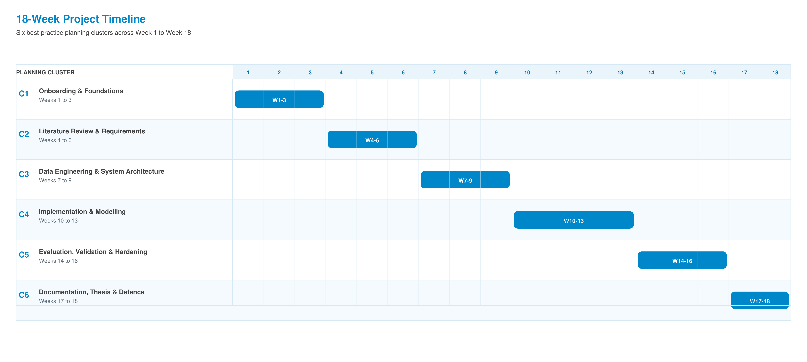

Graha International GmbH
Herzogstandstr. 8 b
85540 Haar
Germany
Contact
E-Mail: info@graha.de

