Graha
Research
Research Internship · 18-Week Gantt Project Plan
ESG Platform with GraphRAG
Build an Environmental, Social and Governance (ESG) analytics platform that uses a Knowledge Graph and Retrieval-Augmented Generation (GraphRAG) to turn fragmented sustainability data into explainable, auditable ESG insights.
18 Weeks 6 Planning Clusters 1 Thesis / Collaboration
Graha International GmbH · Herzogstandstr. 8 b, 85540 Haar, Germany · info@graha.de

Research Internship
Four 18-week Gantt Project Plans for thesis and research collaboration
Graha International GmbH offers four structured research internships, each delivered as an 18-week Gantt Project Plan organised into six best-practice planning clusters. This document details the internship highlighted below.

INTERNSHIP 01  Predictive Maintenance Platform  Design and prototype a predictive-maintenance platform for connected vehicles that combines multivariate time-series modelling, causal AI and explainable remaining-useful-life estimation. | INTERNSHIP 02  ESG Platform with GraphRAG  Build an Environmental, Social and Governance (ESG) analytics platform that uses a Knowledge Graph and Retrieval-Augmented Generation (GraphRAG) to turn fragmented sustainability data into explainable, auditable ESG insights. | INTERNSHIP 03  Digital Product Passport Platform  Implement a Digital Product Passport (DPP) platform for connected-vehicle components that captures lifecycle, material and circularity data in an interoperable, data-sovereign data-space architecture. | INTERNSHIP 04  Digital Twin Platform  Develop a Digital Twin platform that mirrors onboard vehicle systems in real time, fusing sensor telemetry with physics- and data-driven models for simulation, monitoring and what-if analysis.
This document, ESG Platform with GraphRAG
Build an Environmental, Social and Governance (ESG) analytics platform that uses a Knowledge Graph and Retrieval-Augmented Generation (GraphRAG) to turn fragmented sustainability data into explainable, auditable ESG insights.

Our Research Plan
ESG Platform with GraphRAG · 18-Week Gantt Project Plan
Overview
This internship advances Graha International's research at the intersection of Knowledge Graphs, Large Language Models and sustainability reporting. The intern designs and prototypes an ESG platform in which a domain Knowledge Graph and Retrieval-Augmented Generation (GraphRAG) together transform fragmented Environmental, Social and Governance data into explainable, source-traceable insights.
Structured as an 18-week Gantt Project Plan, the work is suitable as the practical basis for a Bachelor's or Master's thesis or a research collaboration. It emphasises factual grounding, auditability and the reduction of hallucinated claims in generated ESG narratives.
Objectives
- Model ESG indicators, entities and relationships in a domain Knowledge Graph.
- Build a GraphRAG pipeline that retrieves graph context to ground LLM responses.
- Generate explainable ESG summaries with explicit source and evidence traceability.
- Reduce hallucinated or unsupported claims compared with standard LLM prompting.
- Evaluate factual grounding, retrieval quality and explanation faithfulness.
Candidate Profile
- Studies in Computer Science, Data Science, Information Systems or a related field.
- Solid Python skills; interest in LLMs, knowledge graphs and information retrieval.
- Basic understanding of graph data models and semantic technologies.
- Interest in sustainability, ESG reporting and trustworthy AI.
- Independent, structured working style and good scientific-writing skills.
18-Week Gantt Project Plan
The plan is organised into six best-practice planning clusters spanning 18 weeks. Each cluster states its focus, key activities and a milestone that must be reached before the next cluster begins.
WEEKS 1-3 Cluster 1 - Onboarding & Foundations
Settle in, set up the working environment, and agree the detailed plan and success criteria with the academic and industrial supervisors.
KEY ACTIVITIES
- Onboarding at Graha International: tooling, data-governance and NDA briefing.
- Familiarisation with ESG frameworks, knowledge graphs and GraphRAG concepts.
- Set up a reproducible environment: version control, experiment tracking and a containerised workspace.
- Refine scope, success criteria and the detailed 18-week work plan with the supervisor.
Milestone, Approved internship work plan and a running, reproducible development environment.

WEEKS 4-6 Cluster 2 - Literature Review & Requirements
Build the scientific foundation through a structured literature review and a precise requirements and evaluation specification.
KEY ACTIVITIES
- Structured literature review on GraphRAG, retrieval-augmented generation and knowledge-graph grounding.
- Survey of ESG reporting standards, taxonomies and disclosure frameworks.
- Stakeholder and requirements analysis; definition of the core use cases and KPIs.
- Draft the conceptual approach and the evaluation methodology with metrics and baselines.
Milestone, Literature-review report and an agreed requirements and evaluation plan.

WEEKS 7-9 Cluster 3 - Data Engineering & System Architecture
Prepare the ESG data assets and design the end-to-end GraphRAG architecture.
KEY ACTIVITIES
- Collect and clean representative ESG documents and structured indicators.
- Design the ESG ontology and Knowledge Graph schema (entities, indicators, relations).
- Design the GraphRAG architecture: ingestion, graph store, retriever, generator and explanation layers.
- Specify the retrieval strategy and the interfaces between components.
Milestone, Architecture design document and a populated ESG Knowledge Graph.

WEEKS 10-13 Cluster 4 - Implementation & Modelling
Implement the GraphRAG platform and the ESG-insight generation components.
KEY ACTIVITIES
- Build the ingestion pipeline that populates and updates the Knowledge Graph.
- Implement graph-aware retrieval that assembles evidence subgraphs for each query.
- Integrate the LLM generation layer with graph context and source citation.
- Build an explainable ESG-summary view with evidence and source traceability.
Milestone, Working ESG GraphRAG prototype covering the core query-to-insight use case.

WEEKS 14-16 Cluster 5 - Evaluation, Validation & Hardening
Evaluate, validate and harden the prototype with a focus on factual grounding.
KEY ACTIVITIES
- Define and run experiments on retrieval quality, factual grounding and explanation faithfulness.
- Compare GraphRAG against standard prompting for hallucination and source coverage.
- Assess robustness to incomplete data; check reproducibility of results.
- Iterate on the graph schema, retrieval and prompting based on the findings.
Milestone, Evaluation report with quantitative results and a validated, hardened prototype.

WEEKS 17-18 Cluster 6 - Documentation, Thesis & Final Defence
Consolidate the documentation, draft the thesis material and present the results.
KEY ACTIVITIES
- Consolidate code, documentation and reproducibility instructions.
- Write the thesis-ready report covering method, results and limitations.
- Prepare and deliver the final presentation and a live demo.
- Hand over the platform, the Knowledge Graph and the backlog of future work to Graha.
Milestone, Final thesis-ready report, final presentation and a complete handover package.

Expected Outcomes
- A reproducible, documented ESG GraphRAG platform prototype.
- A reusable ESG ontology and populated Knowledge Graph.
- An evidence-traceable, explainable ESG-insight generator.
- A thesis-ready scientific report on factual grounding with GraphRAG.
Project Timeline (Gantt Chart)
The 18-week plan visualised as a Gantt chart across Week 1 to Week 18.
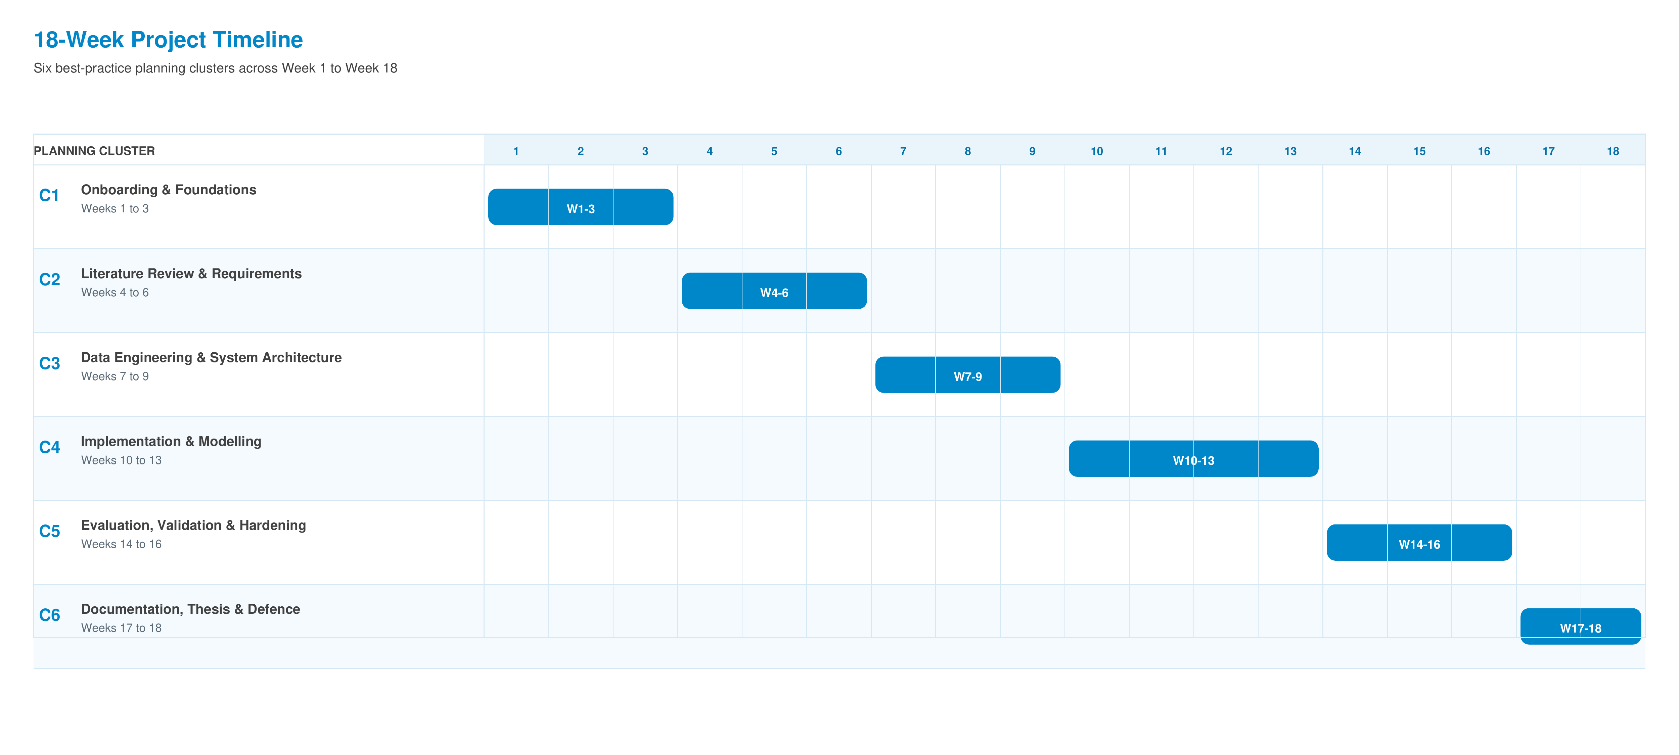

Graha International GmbH
Herzogstandstr. 8 b
85540 Haar
Germany
Contact
E-Mail: info@graha.de

