Graha
Research
Research Internship · 18-Week Gantt Project Plan
Predictive Maintenance Platform
Design and prototype a predictive-maintenance platform for connected vehicles that combines multivariate time-series modelling, causal AI and explainable remaining-useful-life estimation.
18 Weeks 6 Planning Clusters 1 Thesis / Collaboration
Graha International GmbH · Herzogstandstr. 8 b, 85540 Haar, Germany · info@graha.de

Research Internship
Four 18-week Gantt Project Plans for thesis and research collaboration
Graha International GmbH offers four structured research internships, each delivered as an 18-week Gantt Project Plan organised into six best-practice planning clusters. This document details the internship highlighted below.

INTERNSHIP 01  Predictive Maintenance Platform  Design and prototype a predictive-maintenance platform for connected vehicles that combines multivariate time-series modelling, causal AI and explainable remaining-useful-life estimation. | INTERNSHIP 02  ESG Platform with GraphRAG  Build an Environmental, Social and Governance (ESG) analytics platform that uses a Knowledge Graph and Retrieval-Augmented Generation (GraphRAG) to turn fragmented sustainability data into explainable, auditable ESG insights. | INTERNSHIP 03  Digital Product Passport Platform  Implement a Digital Product Passport (DPP) platform for connected-vehicle components that captures lifecycle, material and circularity data in an interoperable, data-sovereign data-space architecture. | INTERNSHIP 04  Digital Twin Platform  Develop a Digital Twin platform that mirrors onboard vehicle systems in real time, fusing sensor telemetry with physics- and data-driven models for simulation, monitoring and what-if analysis.
This document, Predictive Maintenance Platform
Design and prototype a predictive-maintenance platform for connected vehicles that combines multivariate time-series modelling, causal AI and explainable remaining-useful-life estimation.

Our Research Plan
Predictive Maintenance Platform · 18-Week Gantt Project Plan
Overview
This internship contributes to Graha International's research line on advanced predictive maintenance for onboard and offboard vehicle systems. The intern designs and prototypes a Predictive Maintenance (PdM) platform that ingests vehicle telematics time-series, detects anomalies, estimates State of Health (SoH) and Remaining Useful Life (RUL), and produces explainable maintenance recommendations.
The work is structured as an 18-week Gantt Project Plan and is suitable as the practical basis for a Bachelor's or Master's thesis or a research collaboration. It bridges academic inquiry and industrial application, with emphasis on reliability, explainability and reproducibility.
Objectives
- Build a reproducible pipeline for ingesting and cleaning multivariate vehicle telematics time-series.
- Implement and compare anomaly-detection and RUL/SoH estimation models (statistical, ML and deep-learning).
- Integrate a causal-reasoning layer that explains predicted failures rather than only forecasting them.
- Deliver an explainable maintenance-recommendation component with confidence indicators.
- Evaluate the platform against domain-informed ground truth and document the findings.
Candidate Profile
- Studies in Computer Science, Data Science, Electrical/Mechanical Engineering or a related field.
- Solid Python skills; familiarity with pandas, scikit-learn and a deep-learning framework.
- Basic understanding of time-series analysis and machine-learning evaluation.
- Interest in causal inference, explainable AI and connected-vehicle systems.
- Independent, structured working style and good scientific-writing skills.
18-Week Gantt Project Plan
The plan is organised into six best-practice planning clusters spanning 18 weeks. Each cluster states its focus, key activities and a milestone that must be reached before the next cluster begins.
WEEKS 1-3 Cluster 1 - Onboarding & Foundations
Settle in, set up the working environment, and agree the detailed plan and success criteria with the academic and industrial supervisors.
KEY ACTIVITIES
- Onboarding at Graha International: tooling, data-governance and NDA briefing.
- Familiarisation with vehicle telematics, predictive-maintenance concepts and existing Graha assets.
- Set up a reproducible environment: version control, experiment tracking and a containerised workspace.
- Refine scope, success criteria and the detailed 18-week work plan with the supervisor.
Milestone, Approved internship work plan and a running, reproducible development environment.

WEEKS 4-6 Cluster 2 - Literature Review & Requirements
Build the scientific foundation through a structured literature review and a precise requirements and evaluation specification.
KEY ACTIVITIES
- Structured literature review on RUL/SoH estimation, anomaly detection and causal AI for maintenance.
- Survey of relevant time-series imputation methods and predictive-maintenance datasets.
- Stakeholder and requirements analysis; definition of the core use cases and KPIs.
- Draft the conceptual approach and the evaluation methodology with metrics and baselines.
Milestone, Literature-review report and an agreed requirements and evaluation plan.

WEEKS 7-9 Cluster 3 - Data Engineering & System Architecture
Prepare the data assets and design the end-to-end platform architecture.
KEY ACTIVITIES
- Acquire, profile and clean the telematics time-series; handle gaps with selected imputation methods.
- Engineer features and labels for anomaly, SoH and RUL tasks.
- Design the platform architecture: ingestion, processing, modelling, explanation and API layers.
- Specify the data model and the interfaces between components.
Milestone, Architecture design document and a prepared, documented dataset and data pipeline.

WEEKS 10-13 Cluster 4 - Implementation & Modelling
Implement the platform and the predictive and causal-reasoning models.
KEY ACTIVITIES
- Implement the ingestion and processing pipeline as reproducible services.
- Develop and train anomaly-detection and RUL/SoH models; compare statistical, ML and DL approaches.
- Integrate a causal-reasoning layer that links predicted failures to likely root causes.
- Build the explainable maintenance-recommendation component and a minimal review dashboard.
Milestone, Working PdM-platform prototype covering the core anomaly-to-recommendation use case.

WEEKS 14-16 Cluster 5 - Evaluation, Validation & Hardening
Evaluate, validate and harden the prototype against domain-informed ground truth.
KEY ACTIVITIES
- Run controlled experiments; measure precision, recall, RMSE, R-squared and RUL error.
- Validate causal explanations against literature- and domain-derived ground truth.
- Assess robustness to missing data and noise; check reproducibility of results.
- Iterate on the models and the pipeline based on the evaluation findings.
Milestone, Evaluation report with quantitative results and a validated, hardened prototype.

WEEKS 17-18 Cluster 6 - Documentation, Thesis & Final Defence
Consolidate the documentation, draft the thesis material and present the results.
KEY ACTIVITIES
- Consolidate code, documentation and reproducibility instructions.
- Write the thesis-ready report covering method, results and limitations.
- Prepare and deliver the final presentation and a live demo.
- Hand over the platform, datasets and backlog of future work to Graha.
Milestone, Final thesis-ready report, final presentation and a complete handover package.

Expected Outcomes
- A reproducible, documented Predictive Maintenance platform prototype.
- A comparative evaluation of anomaly-detection and RUL/SoH models.
- An explainable, causal maintenance-recommendation component.
- A thesis-ready scientific report and a reusable dataset and pipeline.
Project Timeline (Gantt Chart)
The 18-week plan visualised as a Gantt chart across Week 1 to Week 18.
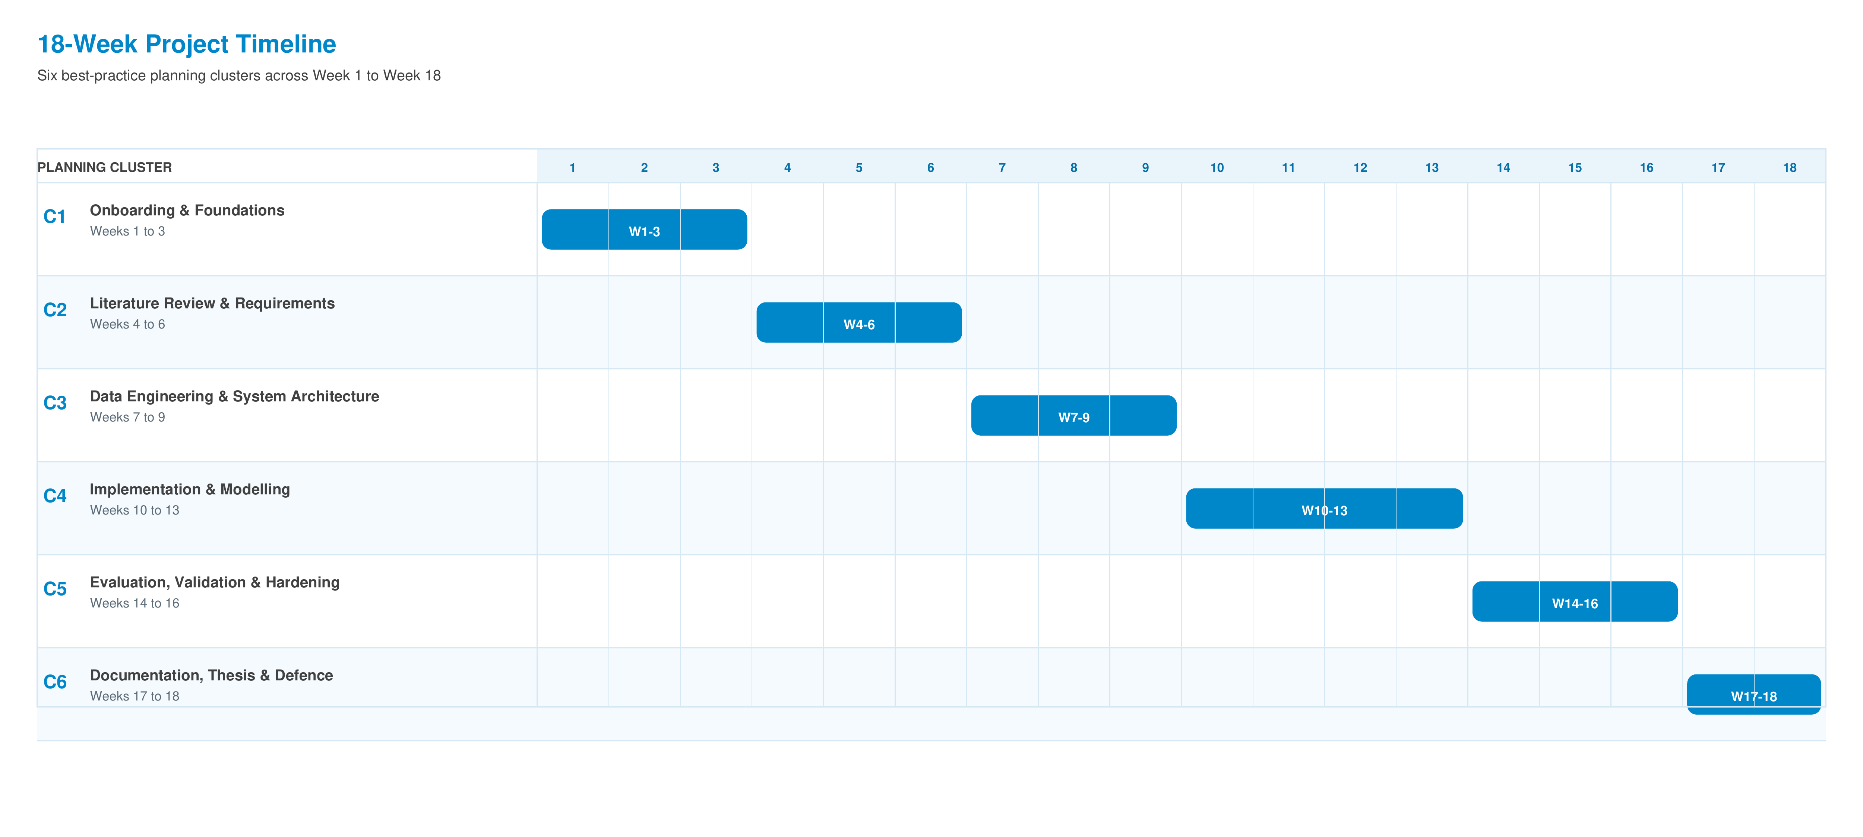

Graha International GmbH
Herzogstandstr. 8 b
85540 Haar
Germany
Contact
E-Mail: info@graha.de

